This SOP describes the field procedures for sampling benthic biomass and seston, as well as the procedures for pre-analytic processing and storage of samples. Sampling should be performed with a sampler of known area. Sampling and sample processing should vary according to the amount of biomass found as well as the physical characteristics of the benthos. This SOP provides a comprehensive methodology for obtaining samples from which biomass, algal pigments, and whatever other analytes of different benthic biomass compartments can be analyzed.

These compartments are (in order of sampling):

### Seston: Organisms and non-living matter in suspension in the water column.

### CPOMa: Coarsely particulated organic matter deposited in the benthos bigger than 1mm. For practical sampling purposes, CPOMa should be defined as the coarse benthic organic matter that is obviously terrestrial, such as branches, twigs and leaves.

### FBOM: Finely particulated organic matter deposited in the benthos that is smaller than 1mm.

### CPOMb: Coarsely particulated organic matter deposited in the benthos bigger than 1mm. This portion of CPOM should be the amorphous portion of the coarse benthic organic matter that cannot be easily identified in the field.

### Filamentous algae: Large filamentous tufts of algae (*Cladophora glomerate*) that are still attached to the benthos.

### Epilithon: Matrix of algae and other microorganisms that grows on top of rocks.

### Macrophytes: Large superior plants that are growing attached to the bottom of the river.

Overall, preparations, sampling, processing and data storage will occur over the course of three consecutive days. This SOP represent the actions to be performed on **Days 0 (Preparations)** and **1 (Sampling)**. For instructions regarding sample processing and data storage, consult the **SOP_Biomass_2_Processing** and the **SOP_Biomass_3_Data_Input_and_ISF_Generation**,respectively.

# Day 0 - Preparation:

## Reagents and materials:

This is a list of all the materials necessary for the biomass sampling.

1. Cooler
2. Ice
3. Pre-Ashed/Weighed 47mm Whattman Glass Fiber Filters (GF-F), see below.
4. Drill Pump Kits
5. Tubing
6. 47mm Glass Fiber Filter Holder
7. Measuring Cylinder
8. Metal sampler **(Feijo-Horner Benthonator 2020TM)**
9. Forceps 1
10. Meter stick
11. 1L plastic bottle (wide mouth)
12. Pickle Bucket
13. 1 mm Metal Sieve
14. Large plastic bags
15. Sample trays – Big
16. Razor blades or knives
17. Scrubbing brushes **(Nylon if doing sampling for Metals)**
18. Whirl Paks (18-24 oz)
19. Squirt Bottles.
20. Field sample sheets
21. Sample ID tags
22. Sharpies
23. Pencils
24. Paper (For large bag labelling)
25. Forceps 2
26. Funnel

## Pre-Ash/Weight filters

For all types of filtered biomass samples, pre-ashing and weighing the filters is of utmost importance. Pre-ashing is the process of burning the filters to remove any biomass contamination.

**Materials:**

1. Whattman GF-F filters
2. Aluminum trays
3. Forceps
4. Muffle Furnace
5. Precision Scale (4 digits)
6. Aluminum Foil
7. Thin Tip Sharpie
8. Separate the filters and spread them in an aluminum tray.
9. The number of filters will depend on the size of the sampling planned. As a general rule:
   * 3 filters per each site (Seston)
   * 2 filters for each substrate sample (FBOM and Epilithon),
     + X 3 replicates.
     + X 3 potential types of substrate to be encountered (Gravel, Pebble, Cobble).
   * Total of 21 filters per site.
   * **SAMPLE NUMBERS WILL VARY BETWEEN PROJECTS AND SITES DEPENING OF OUR KNOWLEDGE OF THE TYPES OF SUBSTRATE PRESENT IN THE AREA. MAKE SURE YOU ARE INFORMED OF THE SAMPLING PLANS BEFORE PROCESSING FILTERS.**
10. Place the filters inside the muffle furnace.
11. Turn on the muffle furnace.
12. Set the muffle furnace temperature to 500oC.
13. Burn the filters for 1h.
14. Turn off the muffle furnace.
15. Open the door slightly and let the interior of the muffle furnace cool down.
    * **THE INSIDE OF THE MUFFLE FURNACE WILL BE EXTREMELLY HOT. WAIT FOR IT TO COOL DOWN AND ALWAYS USE ASBESTHOS GLOVES TO HANDLE CONTENTS.**
16. Remove the filters.
17. Weigh filters individually
    * For biomass related weighing, **ALWAYS** use the older four-digit scale located on the left side of the counter (closer to the printer).
18. For each filter, make an aluminum envelope that can seal completely but can also be easily opened in the field.
    * Glass fiber filters tend to get slightly more brittle after ashing. Make sure your envelope fits the filter in its entirety **without folding** in the center or edges.
19. Write down the weigh of that filter twice in the envelope using a fine tip sharpie.
    * The purpose of the fine tip sharpie is that, even if the ink gets washed out, the indentation in the aluminum will still be visible.
20. Put the filters in a designated Ziploc bag and pack.

## Other items:

1. Print field sheets in Write-in-the-Rain paper.
2. Print Sample tags.
3. Make sure the batteries for the drill pump are charged.

# Day 1 - Field Sampling:

## Habitat characterization

1. Upon arrival at sampling site, measure a 300m reach from which benthic samples will be taken.
2. While measuring the sampling reach, each individual in the sampling crew will make a mental estimate of the distribution of the following categories of benthic substrate: Boulders, Cobbles, Pebbles, Sand.
   * Note: *In case there are better estimates of substrate distribution available, those should be used (e.g.: Drone imagery, satellite imagery).*
   * Sampling will be limited by hoop height.

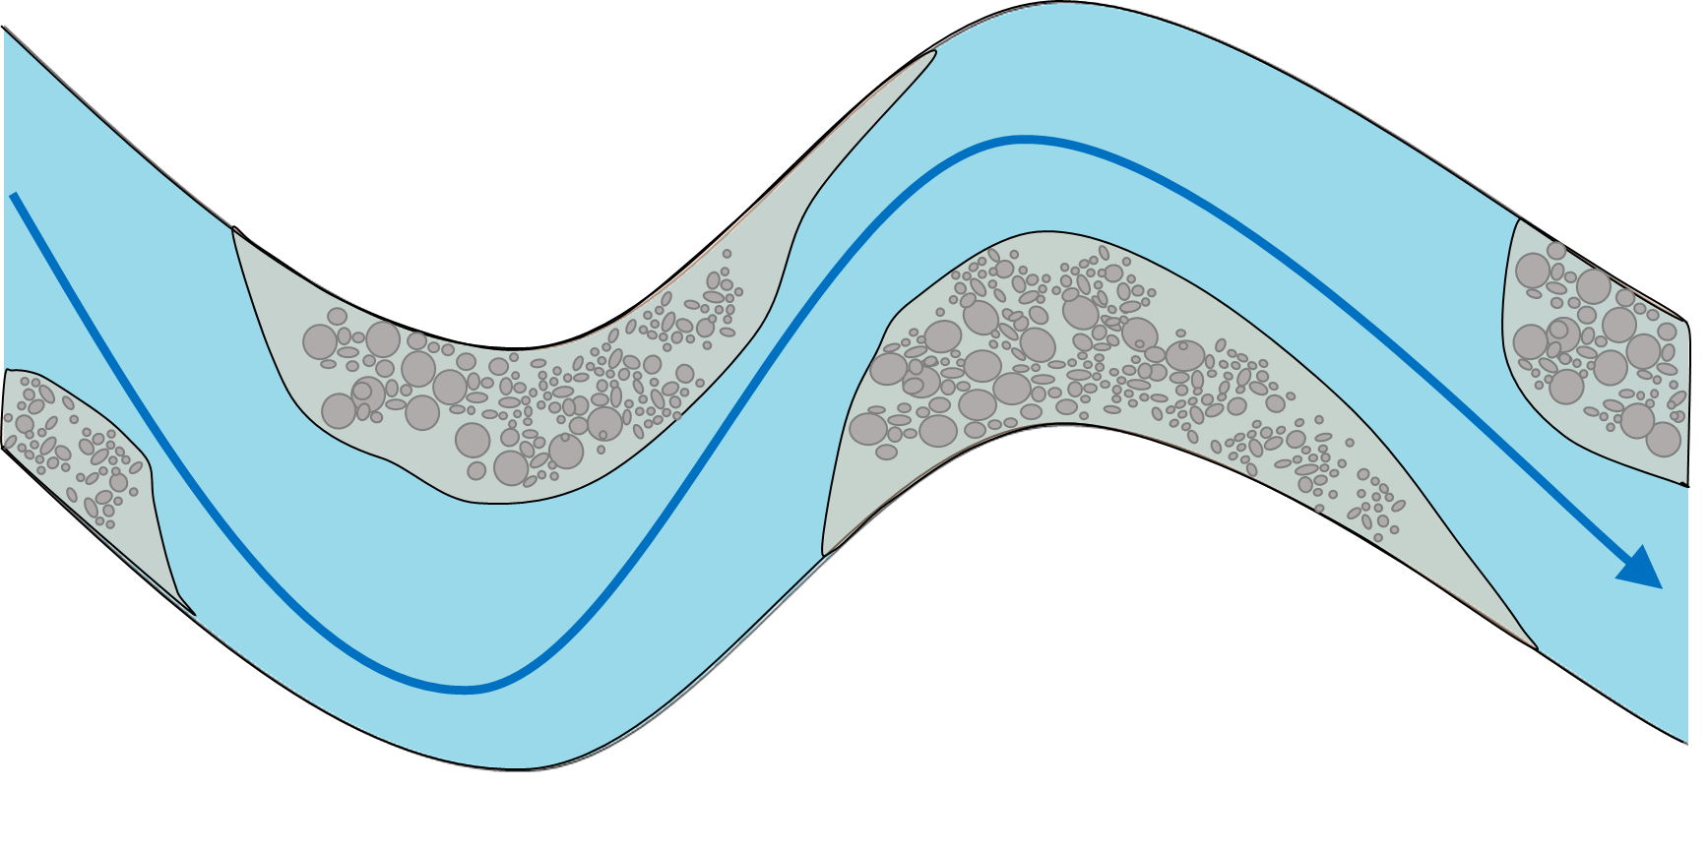

1. Mental estimates of substrate of each crew member should be averaged.
2. If any habitat category averages below 10%, that habitat type will not be sampled.
3. For habitat categories that averaged equals or above 10%, 3 samples will be taken.

## Seston sampling

Seston samples should be collected in **triplicates** at the upstream most point at each

site. This prevents altered measurements caused by other team members disturbing the substrate.

1. Attach the tubing to the EZ-Load pump head.
2. Put a pre-ashed filter inside the filter case.
3. Make sure filter case is properly sealed.
4. Write down the weight of the filter in the field seston spreadsheet.
5. Filter water through the filtration system into the volumetric cylinder.
6. Keep track of the volume.
7. Filter enough water through the filter so that you can obviously perceive that there is material accumulating in the surface. When in doubt, filter more.
8. Write down the final volume in the field seston spreadsheet.
9. Remove the filter carefully from the filter holder.
10. Insert the filter back into the envelope.
11. Before sealing the envelope, fold the filter in half, encasing the side that contains the sample inside. This prevents sample loss due to sticking to the aluminum.
12. Seal the envelope.
13. Put the filter in a labeled bag.

## Benthic sampling:

**Sampling should start from the downstream portion of the reach. Samples should be distributed along the reach in other to be representative of the 300m sampled.**

1. Place the sampler on the bottom of the stream, making sure that it has dug into the sediment, so as to prevent material loss.

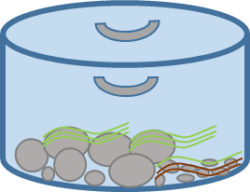

* 1. If substrate is so rocky or uneven that sealing the bottom opening is not possible, a second team member should use the beach towel to prevent FPOM from leaking.

1. Use the meter stick to measure water depth at 4 quadrants inside the sampler. Write those at the appropriate field on the benthic sampling spreadsheet.

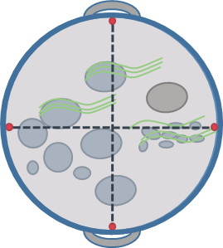

1. Use a Knife or Box Cutter to cut whatever filamentous material is caught around the bottom rim of the sampler.
2. Collect all coarse organic allochthonous material **(Leaves, Branches and Twigs)**. Place those on a separate tray.
3. Place it in a bag with paper labels or appropriately labeled whirl-pak, depending on the size of sample. This will be the **Coarse Benthic Organic Material Sample (CPOM)**.
4. Stir water inside the sampler vigorously to suspend the fine benthic particulates
5. from sampling area.
6. Fill the 1L plastic bottle with the sample to the shoulder. If sampling area not deep enough use plastic bottle, use an appropriately sized Whirl-pak.
   1. Note: *Sample volume does not to be standardized, but make sure there is enough material for AFDM, CHL and whatever other analyses desired.*
7. Strain water out of the bottle using the 1mm sieve through the funnel into a pre labeled Whirl-pak. This will be the **Fine Benthic Organic Material (FBOM) Sample.**
8. Place the contents of the sieve into a separate pre-labeled Whirl-Pak. This will be the **Coarse Particulate Organic Material B (CPOMB) Sample.**
9. Rinse Sieve and funnel between samples.

If sampler area has noticeable amounts of *Cladophora* tufts and/or macrophytes:

1. Remove large plant material and place it in bucket.
2. Bring bucket to shore.
3. Remove all the rocks with more than 2cm of diameter within sampler area and place them in scrubbing trays.
4. If substrate is rocky enough that there is a second layer of rocks under the first one, verify if those have epilithon growing on them. If not, don’t remove those.
5. Bring the tray to shore.

## Field sample processing

1. Strain water out of the bucket using the 1mm sieve.
2. Return material retained in the sieve to the bucket.
3. Place all coarse plant material from the bucket in a plastic bag.
4. If there are macrophyes in the sample, put them in their own bag with a proper identification label. This will be the **Macrophytes** sample.
5. Use a pencil to write down sample ids on at least two tags per bag.
6. If necessary, use more than one bag per sample. Do not squeeze sample in. Squeezing filamentous algae might cause cells to break and cause further deterioration of pigments.
7. Use a pencil to write down sample ids on at least two tags per bag.
8. Place sample ID tags inside the bag.
9. Tie bags loosely and put them in a shaded area. If not available, cover them with a towel.
10. Check the sampled rocks for *Cladophora* tufts.
11. If there are *Cladophora* tufts attached to the rocks, carefully remove them by hand or using a **razor blade.**
12. Scrub the rocks with brush to remove all epilithic material.
13. Rinse repeatedly with the squirt bottle. Make sure you are able to scrub top side of the rocks until it does not feel smooth/slimy to the touch.
    1. *Note: It is really hard to remove ALL material from the rock. Some rocks will still be green no matter how much you scrub them. Make sure that, whatever you do, you are doing the same for all rocks.*
14. After scrubbing, strain the sample through the 1mm sieve into pre labelled whirl paks and place them in the cooler. This will be the **Epilithon** sample.
15. Put the leftover coarse plant materials in the bags, tie them tight and place them in the cooler. This will be the **Filamentous Sample**.